

University Event Management System (UEMS)
Project Management Plan

Course: IT 612 Project Management in IT

Prepared by:
Md. Shakil Hossain 472118102
Dafaallh Alrayh Mustafa 472118115
Ajmal Hamidi 472117941
Zayad Aldajan 472117937
Biliaminu Ishola 472117942

Supervised To:
Dr. Shabana Habib

QASSIM UNIVERSITY
College of Computer | Department of Information Technology
Table of Contents
Executive Summary 5
1. Introduction 6
1.1 Organizational Background 6
1.2 Problem Statement 6
1.3 Project Purpose and Objectives 6
1.4 Scope of This Document 7
2. Project Charter 8
2.1 Project Identification 8
2.2 Business Case 8
2.3 Problem Statement 8
2.4 SMART Objectives 9
2.5 High-Level Requirements 9
2.6 Key Stakeholders 9
2.7 Assumptions and Constraints 10
Assumptions 10
Constraints 10
2.8 Project Manager Authority 10
3. Project Life Cycle Model 11
3.1 Selected Methodology 11
3.2 Process Groups Overview 11
3.3 Phase Descriptions 11
Initiation Phase (Week 1) 11
Planning Phase (Weeks 2–5) 11
Execution Phase (Weeks 6–8) 12
Monitoring and Controlling (Continuous) 12
Closing Phase (Weeks 9–10) 12
3.4 Life Cycle Diagram 12
4. Project Integration Management 14
4.1 Overall Project Management Approach 14
4.2 Change Control Process 14
4.3 Configuration Management 14
4.4 Lessons Learned Process 15
5. Scope Management Plan 16
5.1 Scope Planning Approach 16
5.2 Detailed Scope Statement 16
In Scope 16
Out of Scope 16
5.3 Work Breakdown Structure (WBS) 17
5.4 WBS Dictionary (Selected Work Packages) 19
5.5 Scope Validation and Control 19
6. Schedule Management Plan 20
6.1 Schedule Development Approach 20
6.2 Activity List 20
6.3 Activity Sequencing and Network Diagram 21
6.4 Gantt Chart Summary 22
6.5 Critical Path Analysis 23
6.6 Schedule Control 23
7. Cost Management Plan 24
7.1 Cost Estimation Approach 24
7.2 Detailed Cost Breakdown 24
7.3 Cost Baseline 25
7.4 Cost Control 25
8. Quality Management Plan 26
8.1 Quality Standards 26
8.2 Quality Assurance (QA) Plan 26
8.3 Quality Control (QC) Plan 26
8.4 Acceptance Criteria 27
8.5 Defect Management 27
9. Human Resource Management Plan 28
9.1 Team Structure 28
9.2 RACI Matrix 28
9.3 Team Development Plan 29
9.4 Conflict Resolution 29
10. Communication Management Plan 30
10.1 Communication Objectives 30
10.2 Communication Matrix 30
10.3 Communication Tools and Infrastructure 30
10.4 Reporting Structure 31
10.5 Meeting Schedule 31
11. Risk Management Plan 32
11.1 Risk Management Approach 32
11.2 Risk Probability-Impact Scales 32
11.3 Risk Register 32
11.4 Risk Monitoring 34
12. Procurement Management Plan 35
12.1 Procurement Strategy 35
12.2 Make-or-Buy Analysis 35
12.3 Vendor Selection Criteria 36
12.4 Contract Types 36
12.5 Procurement Timeline 36
13. Stakeholder Management Plan 37
13.1 Stakeholder Identification Approach 37
13.2 Stakeholder Register 37
13.3 Power-Interest Grid 38
13.4 Stakeholder Engagement Strategy 38
Manage Closely (High Power, High Interest) 38
Keep Satisfied (High Power, Low Interest) 38
Keep Informed (Low Power, High Interest) 38
Monitor (Low Power, Low Interest) 38
13.5 Resistance Management 38
14. Conclusion 39

Executive Summary
This Project Management Plan (PMP) presents a comprehensive, professional-grade blueprint for the development of the University Event Management System (UEMS) at Qassim University. Qassim University, located in Buraidah in the Qassim region of Saudi Arabia, is one of the Kingdom's leading academic institutions under the College of Computer, Department of Information Technology. The university currently manages hundreds of academic and non-academic events including conferences, seminars, workshops, cultural festivals, and graduation ceremonies through predominantly manual and fragmented processes.
The existing manual approach to event management has created persistent operational challenges: scheduling conflicts between academic and non-academic events, poor communication among organizers and participants, budget mismanagement due to inadequate tracking mechanisms, and low efficiency in participant registration and attendance monitoring. These challenges have a direct impact on the university's administrative effectiveness and on the experience of its students, faculty, and external guests.
The UEMS is envisioned as a centralized, web-based digital platform that will automate the full lifecycle of event management from event creation, venue booking, and registration to participant communication, budget tracking, and post-event reporting. The system will serve multiple user roles including students, faculty, administrative staff, and university management.
This document covers all thirteen Project Management Knowledge Areas as defined by the Project Management Institute (PMI) PMBOK Guide, Seventh Edition, including: Integration Management, Scope Management, Schedule Management, Cost Management, Quality Management, Human Resource Management, Communications Management, Risk Management, Procurement Management, and Stakeholder Management.
The project is planned for completion within a 10-week academic timeline from February to April 2026, with a total estimated budget of SAR 285,000. The plan includes a comprehensive Work Breakdown Structure (WBS), Gantt chart, risk register with 10+ identified risks, RACI matrix, stakeholder register, and cost baseline.
This plan does not cover the actual software development of UEMS; rather, it provides the authoritative management framework that would govern the development project from initiation through closure, ensuring alignment with Qassim University's strategic objectives and the Saudi Vision 2030 initiative to digitize public service delivery.

1. Introduction

1.1 Organizational Background
Qassim University (QU) is a comprehensive public university established in 2004, headquartered in Buraidah, Qassim Region, Kingdom of Saudi Arabia. The university operates under the supervision of the Ministry of Education and serves a student population of over 60,000 across a wide range of undergraduate and postgraduate programs. The College of Computer within QU houses several departments including the Department of Information Technology (IT), which is responsible for developing technology-related competencies and digital solutions that serve both academic and administrative functions.
The Information Technology Department offers programs aligned with modern IT practices, preparing graduates to contribute to Saudi Arabia's growing digital economy in line with Vision 2030. The department regularly organizes academic events such as technical workshops, programming competitions, capstone project exhibitions, and research conferences.

1.2 Problem Statement
Currently, event management across Qassim University is conducted through a decentralized, manual process. Department administrators use a combination of phone calls, emails, paper-based forms, and shared spreadsheets to coordinate event logistics. This approach suffers from multiple systemic weaknesses:
- Scheduling conflicts arise when multiple events are booked in the same venue without a centralized booking system.
- Communication gaps between event organizers, participants, and university management lead to confusion and poor attendance.
- Budget mismanagement occurs because financial tracking is handled informally, making it difficult to reconcile expenditures against approved budgets.
- Participant tracking is inefficient; registration, attendance, and feedback collection rely on paper forms that are time-consuming to process.
- Event history and analytics are not systematically captured, preventing data driven decision making.

1.3 Project Purpose and Objectives
The purpose of this project is to plan the development of the University Event Management System (UEMS), a centralized digital platform that will resolve the identified challenges. The objectives of this project are:
- Deliver a complete, PMBOK-aligned Project Management Plan for the UEMS development project within 10 weeks.
- Define the project scope, schedule, budget, and quality standards with sufficient detail for execution.
- Identify and plan for all major project risks, ensuring mitigation strategies are in place prior to development.
- Establish stakeholder engagement and communication protocols to ensure alignment throughout the project.
- Provide procurement and HR plans that support efficient resource acquisition and team management.

1.4 Scope of This Document
This Project Management Plan covers the planning phase of the UEMS project. It does not include actual system development, coding, or deployment. All sections follow the PMBOK Guide knowledge area framework and are designed to simulate a real-world IT project management scenario in an academic context.

2. Project Charter

2.1 Project Identification
Project Title | University Event Management System (UEMS)
Project Sponsor | Qassim University – Office of the Rector
Sponsoring College | College of Computer, Department of Information Technology
Project Manager | IT Project Management Team Lead
Start Date | February 1, 2026
Planned End Date | April 30, 2026
Duration | 10 Weeks (2.5 Months)
Total Budget | SAR 285,000
Priority | High – Strategic Digital Transformation Initiative

2.2 Business Case
Qassim University manages hundreds of academic and social events each year across its expansive campus. The absence of a unified digital event management platform results in recurring inefficiencies estimated to cost the university over SAR 120,000 annually in lost productive time, duplicate resource allocation, and emergency budget adjustments. Additionally, the university's commitment to Saudi Vision 2030 and its institutional digital transformation strategy necessitates the modernization of core administrative processes, of which event management is a critical component.
The UEMS will directly improve operational efficiency, reduce administrative overhead, enhance student and faculty experience, and provide university management with real-time data for strategic decision-making. The return on investment is expected to be realized within 18 months of system deployment through measurable reductions in scheduling conflicts, manual processing time, and budget variances.

2.3 Problem Statement
Qassim University currently lacks a centralized system for managing academic and non-academic events. Manual coordination through emails, phone calls, and paper forms leads to scheduling conflicts, communication failures, budget mismanagement, and poor participant tracking, undermining the university's administrative effectiveness and stakeholder satisfaction.

2.4 SMART Objectives
SMART | Criterion | Objective
S | Specific | Develop a centralized web-based University Event Management System for QU.
M | Measurable | Reduce scheduling conflicts by 90% and manual processing time by 75% within 6 months of deployment.
A | Achievable | Complete planning within 10 weeks using available IT department expertise and university infrastructure.
R | Relevant | Aligns with QU digital transformation goals and Saudi Vision 2030 e-governance objectives.
T | Time-bound | Complete the full Project Management Plan by April 30, 2026.

2.5 High-Level Requirements
- Centralized event creation and management module accessible by authorized university staff.
- Online participant registration with automated confirmation and notification via email and SMS.
- Venue and resource booking with real-time conflict detection and resolution.
- Budget tracking module with approval workflows and variance reporting.
- Participant attendance management with QR-code-based check-in support.
- Post-event feedback collection and analytics dashboard.
- Role-based access control for students, faculty, event coordinators, and administrators.
- Integration with existing Qassim University student and HR information systems (MyQU portal).
- Mobile-responsive interface accessible via web browsers on desktop and mobile devices.
- Arabic and English bilingual interface to serve all university stakeholders.

2.6 Key Stakeholders
Stakeholder | Role | Interest
Rector's Office | Project Sponsor | Strategic oversight, institutional compliance, ROI
IT Department Head | Technical Sponsor | Technical feasibility, resource allocation
Project Manager | PM Lead | Project delivery within scope, time, cost
Development Team | Implementers | Clear requirements, realistic timelines
Event Coordinators | Primary Users | Ease of use, reliable scheduling tools
Students | End Users | Smooth registration, event discovery
Faculty Members | End Users | Efficient event organization support
QU IT Infrastructure | Technical Support | System integration, hosting, security

2.7 Assumptions and Constraints

Assumptions
- The university will provide access to the existing MyQU portal APIs for system integration.
- All required software licenses will be available within the budget.
- Faculty and staff will be available to participate in requirements-gathering sessions.
- The hosting infrastructure exists within the university IT environment.

Constraints
- The project planning phase must be completed within 10 academic weeks.
- The total project budget is capped at SAR 285,000.
- The system must comply with the Saudi National Cybersecurity Authority (NCA) data protection standards.
- All project documentation must be submitted in both Arabic and English.

2.8 Project Manager Authority
The Project Manager is authorized to: approve changes within a 10% variance of the approved budget (up to SAR 28,500); allocate team members to tasks; make decisions on technical approach within agreed architectural guidelines; escalate unresolved issues to the IT Department Head within 24 hours; and approve vendor selections for low-value procurement (under SAR 10,000) without sponsor approval.

3. Project Life Cycle Model

3.1 Selected Methodology
This project adopts a Waterfall (Predictive) life cycle model, which is appropriate given the clearly defined requirements, fixed academic deadline, and regulatory environment of a public university in Saudi Arabia. The waterfall model provides clear phase gates, structured approval workflows, and comprehensive documentation all aligned with the project's academic and institutional objectives.
The project will follow the five Process Groups defined by PMI PMBOK: Initiation, Planning, Execution, Monitoring & Controlling, and Closing.

3.2 Process Groups Overview
Phase | Duration | Key Activities
Initiation | Week 1 | Charter approval, stakeholder identification, feasibility assessment
Planning | Weeks 2–5 | Scope definition, WBS, schedule, cost, quality, risk, procurement, HR, communication plans
Execution | Weeks 6–8 (simulated) | System design, module development, integration, UAT
Monitoring & Control | Concurrent | Progress tracking, change control, risk monitoring, status reporting
Closing | Weeks 9–10 | Final delivery, lessons learned, sign-off, documentation archiving

3.3 Phase Descriptions

Initiation Phase (Week 1)
The initiation phase formally authorizes the project. Activities include the development and approval of the Project Charter, identification of all key stakeholders, appointment of the Project Manager, and a preliminary feasibility review. Deliverables include the signed Project Charter and the initial Stakeholder Register. The phase gate exit criterion requires formal written approval from the Rector's Office and IT Department Head.

Planning Phase (Weeks 2–5)
The planning phase is the most comprehensive phase, producing all management plans. The project team conducts stakeholder requirements-gathering sessions, defines the detailed project scope, constructs the Work Breakdown Structure (WBS), develops the project schedule, estimates costs, and creates all subsidiary management plans. This phase's output is the complete, approved Project Management Plan which is the primary deliverable of this academic project.

Execution Phase (Weeks 6–8)
In a real deployment, the execution phase would involve the software development team implementing UEMS modules according to the approved design specifications. Work packages from the WBS would be assigned to team members, and progress would be tracked against the baseline. For this academic project, the execution phase is simulated through the development of realistic plans, prototypes, and decision artifacts.

Monitoring and Controlling (Continuous)
Throughout all phases, monitoring and controlling activities ensure the project remains on track. The Project Manager holds weekly status meetings, reviews the risk register, tracks schedule performance using Earned Value Management (EVM) metrics, and manages the change control process. Any deviation from baselines exceeding 10% triggers a corrective action report.

Closing Phase (Weeks 9–10)
The closing phase involves finalizing all project work, conducting a lessons-learned session, obtaining formal sign-off from the sponsor, archiving all project documentation, and delivering the final management report. The academic deliverable and the final presentation constitute the formal project closure artifacts.

3.4 Life Cycle Diagram
The following table illustrates the project life cycle phases, their timing, and primary outputs across the 10-week timeline:
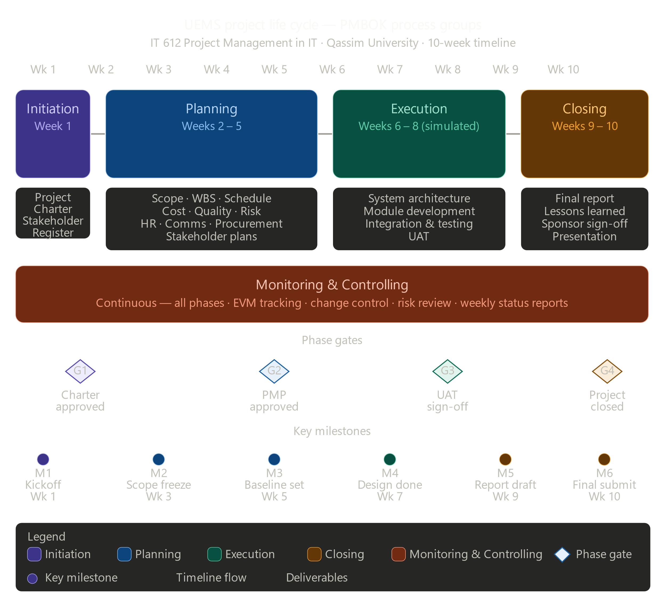
Figure 3.4.1: UEMS Life Cycle Diagram.

4. Project Integration Management

4.1 Overall Project Management Approach
Project Integration Management ensures that all project processes and activities are coordinated cohesively. For the UEMS project, integration management centers on the Project Manager as the single point of accountability for all management decisions. The Project Management Plan serves as the authoritative reference document for all project activities, and any changes must be processed through the formal change control process.
The Project Manager will conduct a weekly integration review meeting every Sunday from 10:00–11:00 AM, attended by all team leads. Meeting minutes will be circulated within 24 hours. The Project Manager will maintain a project dashboard updated weekly on the MyQU project portal, summarizing schedule, cost, risk, and quality status using a Red-Amber-Green (RAG) rating system.

4.2 Change Control Process
All changes to the project's approved baseline (scope, schedule, or cost) must follow the Integrated Change Control (ICC) process:
- Change Requestor submits a Change Request Form (CRF) to the Project Manager, describing the change, rationale, and impact.
- The Project Manager assesses the impact on scope, schedule, cost, quality, and risk within 48 hours.
- For changes within the PM's authority threshold (≤10% budget variance), the PM approves or rejects and documents the decision.
- For changes exceeding the PM's authority, the Change Control Board (CCB) comprising the PM, IT Department Head, and Finance representative convenes within 5 business days.
- All approved changes are incorporated into the baseline documents and communicated to all stakeholders.
- Rejected changes are documented with rationale and filed in the project records.

4.3 Configuration Management
All project documents and deliverables will be version controlled using a naming convention that includes the document type, version number, and date (e.g., UEMS_ScopeStatement_v1.2_20260215). Documents will be stored on the university's Microsoft SharePoint platform, organized by phase. Access permissions are defined in the Communications Management Plan. The Project Manager must approve any release of a document as a formal project deliverable.

4.4 Lessons Learned Process
Lessons learned will be collected throughout the project using a structured Lessons Learned Register. At the end of each phase, the team will hold a 30-minute retrospective to identify what went well, what could be improved, and what should be done differently. The final lessons learned report will be submitted to the IT Department's knowledge repository to benefit future projects at Qassim University.

5. Scope Management Plan

5.1 Scope Planning Approach
Scope management defines what is included in and excluded from the UEMS project. The scope will be defined through structured requirements-gathering sessions with key user groups, followed by formal documentation and stakeholder approval.

5.2 Detailed Scope Statement

In Scope
- Design and specification of the UEMS web application, including all functional modules.
- Event creation and management module.
- Participant registration module with email and SMS notifications.
- Venue and resource booking module with real-time conflict detection.
- Budget management module with multi-level approval workflow.
- Attendance tracking module with QR-code check-in capability.
- Feedback and survey module for post-event evaluation.
- Role-based user management (Admin, Coordinator, Faculty, Student roles).
- Integration specification with existing MyQU portal authentication (SSO).
- Bilingual interface specification (Arabic and English).
- System testing plan covering unit, integration, and user acceptance testing.

Out of Scope
- Actual software development and coding of the UEMS application.
- Hardware procurement and physical infrastructure setup.
- Training and deployment after system development.
- Integration with external third-party event platforms.
- Mobile application development (iOS/Android); the system is web-responsive only.

5.3 Work Breakdown Structure (WBS)
The WBS decomposes the total project scope into manageable work packages. The following represents the top three levels of the WBS:
L1 | L2 Phase | L3 Deliverable | L4 Work Package | Est. Hours
1.0 Introduction | 1.1 Initiation | 1.1.1 Charter Development | Project Charter Document | 16
 | 1.1 Initiation | 1.1.2 Stakeholder ID | Stakeholder Register v1 | 8
 | 1.2 Planning | 1.2.1 PMP Development | All subsidiary plans | 120
 | 1.3 Monitoring | 1.3.1 Status Reports | 10× Weekly Reports | 20
 | 1.4 Closing | 1.4.1 Lessons Learned | Lessons Learned Report | 8
2.0 Requirements | 2.1 Elicitation | 2.1.1 Stakeholder Interviews | Interview Notes (10 sessions) | 20
 | 2.2 Documentation | 2.2.1 Requirements Spec | SRS Document | 40
 | 2.3 Validation | 2.3.1 Requirements Sign-off | Signed approval | 8
3.0 System Design | 3.1 Architecture | 3.1.1 Tech Stack Selection | Architecture Decision Record | 16
 | 3.1 Architecture | 3.1.2 System Architecture Doc | Architecture Diagram | 24
 | 3.2 Database | 3.2.1 Data Model Design | ERD + Schema | 20
 | 3.3 UI/UX | 3.3.1 Wireframes | 30+ screen wireframes | 40
 | 3.3 UI/UX | 3.3.2 UI Prototype | Interactive Figma prototype | 24
4.0 Development | 4.1 Event Module | 4.1.1 Event CRUD | Tested event management functions | 80
 | 4.2 Registration | 4.2.1 Registration Module | Registration + notification system | 60
 | 4.3 Venue Booking | 4.3.1 Booking Engine | Conflict detection module | 50
 | 4.4 Budget Module | 4.4.1 Budget Tracker | Budget management + approval | 60
 | 4.5 Attendance | 4.5.1 QR Check-in | QR generation + scanning module | 40
 | 4.6 Feedback | 4.6.1 Survey Module | Post-event survey tool | 30
5.0 Integration | 5.1 MyQU SSO | 5.1.1 SSO Integration | Authentication integration | 24
 | 5.2 Testing | 5.2.1 Unit Testing | Unit test suite | 40
 | 5.3 Testing | 5.3.1 Integration Testing | Integration test results | 30
 | 5.4 Testing | 5.4.1 UAT Execution | UAT report + sign-off | 50
6.0 Documentation | 6.1 Technical Docs | 6.1.1 API Documentation | API Reference Guide | 16
 | 6.2 User Manuals | 6.2.1 User Guide | Bilingual user manual | 24
 | 6.3 Training | 6.3.1 Training Materials | Training slide deck + videos | 20
7.0 Deployment | 7.1 Strategy | 7.1.1 Deployment Plan | Go-live plan document | 16
 | 7.2 Support | 7.2.1 Support Plan | Post-launch support procedures | 12

5.4 WBS Dictionary (Selected Work Packages)
ID | Work Package | Description | Responsible | Estimated Hours
1.2 | PMP Development | All 13 knowledge area plans | PM + All Leads | 120 hrs
2.2 | Requirements Document | Functional & non-functional requirements specification | Business Analyst | 40 hrs
3.1 | Architecture Design | System architecture, tech stack, integration design | Lead Architect | 60 hrs
4.1 | Event Module | Development of event creation, listing, and management functions | Dev Team A | 80 hrs
5.4 | UAT | User Acceptance Testing with 20 test participants | QA Lead + Users | 50 hrs

5.5 Scope Validation and Control
Scope validation will be conducted at the end of each major phase through a formal review meeting with the project sponsor and key users. Each deliverable will be assessed against its defined acceptance criteria before sign-off. Any work that falls outside the approved scope will be handled through the change control process described in Section 4.2. Scope creep will be actively monitored through weekly scope status reports and a formal scope baseline logged in the project management tool.

6. Schedule Management Plan

6.1 Schedule Development Approach
The project schedule is developed using a bottom-up estimation approach, decomposing the WBS work packages into individual activities, estimating durations, defining dependencies, and identifying the critical path. The schedule baseline is maintained in a Gantt chart format, and performance is tracked using Earned Value Management (EVM) metrics.

6.2 Activity List
ID | Activity | Start | End | Duration | Pred.
A1 | Project Charter Development | Wk 1, Day 1 | Wk 1, Day 5 | 5 days | —
A2 | Stakeholder Identification | Wk 1, Day 3 | Wk 1, Day 5 | 3 days | A1
A3 | Requirements Gathering | Wk 2, Day 1 | Wk 2, Day 5 | 5 days | A1,A2
A4 | Scope Statement & WBS | Wk 3, Day 1 | Wk 3, Day 5 | 5 days | A3
A5 | Schedule Development | Wk 4, Day 1 | Wk 4, Day 3 | 3 days | A4
A6 | Cost Estimation & Budget | Wk 4, Day 3 | Wk 5, Day 2 | 5 days | A4
A7 | Risk Identification & Analysis | Wk 5, Day 3 | Wk 6, Day 2 | 5 days | A4
A8 | Quality Plan | Wk 5, Day 1 | Wk 5, Day 3 | 3 days | A4
A9 | HR & Communication Plans | Wk 6, Day 1 | Wk 6, Day 3 | 3 days | A4
A10 | Procurement Plan | Wk 6, Day 3 | Wk 6, Day 5 | 3 days | A6
A11 | System Architecture Design | Wk 6, Day 1 | Wk 7, Day 5 | 8 days | A3
A12 | Prototype/Wireframe Design | Wk 7, Day 1 | Wk 8, Day 2 | 6 days | A11
A13 | Plan Review & Revision | Wk 8, Day 1 | Wk 9, Day 3 | 8 days | A1-A12
A14 | Final Report Writing | Wk 9, Day 1 | Wk 9, Day 5 | 5 days | A13
A15 | Final Presentation Preparation | Wk 10, Day 1 | Wk 10, Day 3 | 3 days | A14
A16 | Submission & Presentation | Wk 10, Day 4 | Wk 10, Day 5 | 2 days | A15

6.3 Activity Sequencing and Network Diagram
Activity sequencing uses Finish-to-Start (FS) dependencies as the primary relationship type. Key dependency chains are as follows:
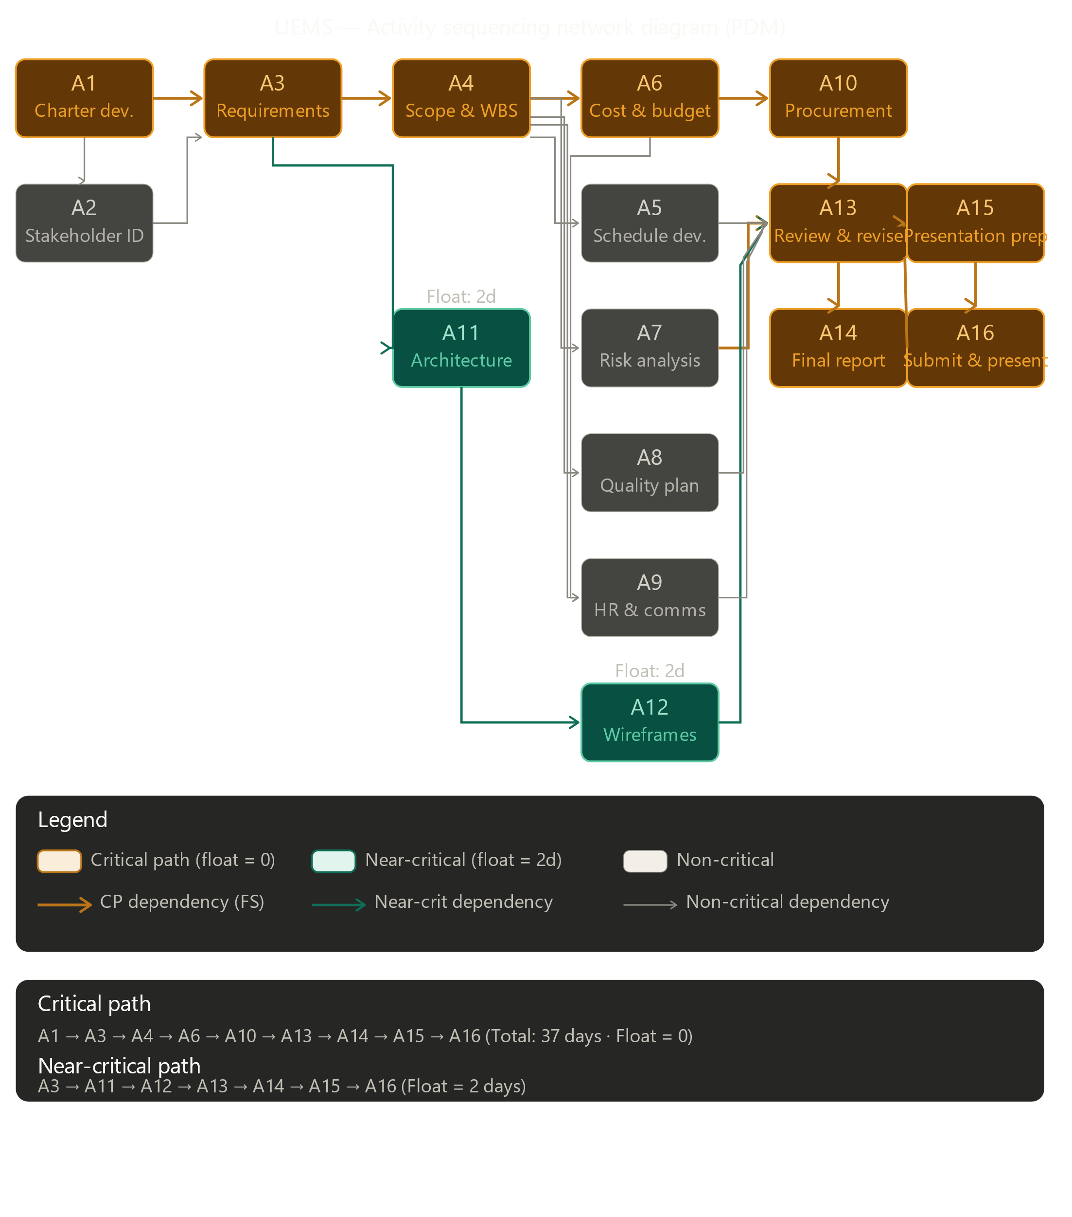
Figure 6.3.1: Activity Network Diagram using the Precedence Diagramming Method (PDM).

- Critical Path 1: A1 → A3 → A4 → A6 → A10 → A13 → A14 → A15 → A16 (Total: 37 days)
- Critical Path 2: A1 → A3 → A4 → A7 → A13 → A14 → A15 → A16 (Total: 35 days)
- Near-Critical: A11 → A12 runs in parallel with risk and quality planning (float: 2 days)
The critical path runs through requirements → scope → cost → procurement → revision → reporting → presentation, giving a total project float of zero on this chain. The Project Manager will monitor critical path activities weekly to prevent schedule slippage.

6.4 Gantt Chart Summary
Activity | W1 | W2 | W3 | W4 | W5 | W6 | W7 | W8 | W9 | W10
A1: Project Charter | ███
A2: Stakeholder ID | ███
A3: Requirements Gathering |  | ███
A4: Scope & WBS |  |  | ███
A5: Schedule Development |  |  |  | ███
A6: Cost & Budget |  |  |  | ███ | ███
A7: Risk Analysis |  |  |  |  | ███ | ███
A8: Quality Plan |  |  |  |  | ███
A9: HR & Communication |  |  |  |  |  | ███
A10: Procurement Plan |  |  |  |  |  | ███
A11: Architecture Design |  |  |  |  |  | ███ | ███
A12: Wireframe Design |  |  |  |  |  |  | ███ | ███
A13: Plan Review & Revision |  |  |  |  |  |  |  | ███ | ███
A14: Final Report Writing |  |  |  |  |  |  |  |  | ███
A15: Presentation Prep |  |  |  |  |  |  |  |  |  | ███
A16: Submission |  |  |  |  |  |  |  |  |  | ███

6.5 Critical Path Analysis
The Critical Path Method (CPM) analysis identifies
A1→A3→A4→A6→A10→A13→A14→A15→A16 as the critical path with zero total float. Any delay in these activities will directly delay the project completion. Activities on the near-critical path (A11, A12) have a total float of only 2 days and should be monitored closely. The project schedule includes a 3-day buffer in Week 10 to accommodate minor delays in report finalization.

6.6 Schedule Control
Schedule performance will be tracked using Earned Value Analysis (EVA). The key metrics used are: Schedule Performance Index (SPI = EV/PV) and Schedule Variance (SV = EV-PV). An SPI below 0.9 will trigger an escalation to the IT Department Head. Weekly schedule reports will be prepared and circulated every Sunday evening.

7. Cost Management Plan

7.1 Cost Estimation Approach
Cost estimation for the UEMS project uses a bottom-up estimation approach, building from individual work package cost estimates and aggregating to the total project budget. Estimates are based on Saudi market rates for IT professionals as of Q1 2026, historical data from similar QU IT projects, and vendor quotations for software licenses and hardware.

7.2 Detailed Cost Breakdown
Cat. | Item | Qty / Unit | Unit Cost (SAR) | Total (SAR)
Labor | Project Manager (10 weeks × 40 hrs/wk) | 400 hrs | 200 SAR/hr | 80,000
Labor | Senior Developer × 2 (6 weeks × 40 hrs/wk) | 480 hrs | 175 SAR/hr | 84,000
Labor | Business Analyst (4 weeks × 40 hrs/wk) | 160 hrs | 150 SAR/hr | 24,000
Labor | UI/UX Designer (3 weeks × 40 hrs/wk) | 120 hrs | 140 SAR/hr | 16,800
Labor | QA/Test Engineer (3 weeks × 40 hrs/wk) | 120 hrs | 130 SAR/hr | 15,600
Software | Web Server License (Apache/Nginx — open source) | 1 yr | 0 | 0
Software | Database License (MySQL — community edition) | 1 yr | 0 | 0
Software | SMS Gateway API Subscription (12 months) | 12 mo | 1,500 SAR/mo | 18,000
Software | Email Service API (SendGrid — business plan) | 12 mo | 750 SAR/mo | 9,000
Hardware | Cloud Hosting / VPS Server (2-year commitment) | 2 yrs | 7,500 SAR/yr | 15,000
Hardware | QR Code Scanner Hardware (check-in devices × 5) | 5 units | 800 SAR | 4,000
Testing | UAT Coordination & Participant Compensation | Lump sum | — | 5,000
Other | Contingency Reserve (10% of direct costs) | — | — | 27,140
TOTAL |  |  |  | 298,540

Note: The approved budget is SAR 285,000. The contingency reserve of SAR 27,140 will be drawn from the management reserve authorized by the project sponsor. Total project cost including all reserves is SAR 298,540.

7.3 Cost Baseline
The cost baseline represents the time-phased budget against which project expenditure will be measured. The cumulative S-curve expenditure distribution across the 10-week project is:
Item | W1 | W2 | W3 | W4 | W5 | W6 | W7 | W8 | W9 | W10
Planned Spend (SAR '000) | 8 | 18 | 22 | 28 | 26 | 42 | 48 | 36 | 24 | 16
Cumulative (SAR '000) | 8 | 26 | 48 | 76 | 102 | 144 | 192 | 228 | 252 | 268

7.4 Cost Control
Cost performance will be measured using Earned Value Management (EVM). Key metrics monitored include: Cost Performance Index (CPI = EV/AC), Cost Variance (CV = EV - AC), and Estimate at Completion (EAC = BAC/CPI). A CPI below 0.9 will trigger a cost review meeting with the sponsor. Weekly cost reports will include actuals against the baseline with variance explanations.

8. Quality Management Plan

8.1 Quality Standards
The UEMS project will adhere to the following quality standards and frameworks:
- ISO/IEC 25010 (Software Quality Model) for system and software quality requirements.
- ISO 9001:2015 for overall project quality management processes.
- Saudi National Cybersecurity Authority (NCA) Essential Cybersecurity Controls (ECC-1:2018) for security quality.
- WCAG 2.1 Level AA for web accessibility, ensuring the system is usable by individuals with disabilities.
- QU Internal IT Project Quality Standards as defined by the Deanship of IT Affairs.

8.2 Quality Assurance (QA) Plan
Quality Assurance activities are proactive measures taken throughout the project to ensure processes are followed correctly. QA activities include:
- Weekly process audits to verify adherence to the Project Management Plan.
- Peer reviews of all major deliverables by at least one qualified reviewer before submission.
- Code review sessions for all developed modules, requiring sign-off from the Lead Architect before integration.
- Sprint-end retrospectives to evaluate process effectiveness and make improvements.
- Independent QA reviews at major phase gates before proceeding to the next phase.

8.3 Quality Control (QC) Plan
Quality Control activities are reactive inspection measures to verify that deliverable outputs meet defined standards. QC activities include:
- Functional testing of all UEMS modules against the requirements traceability matrix.
- Performance testing to verify the system supports at least 500 concurrent users without response degradation.
- Security testing including penetration testing and vulnerability scanning before UAT.
- Bilingual interface testing to verify correct rendering and functionality in both Arabic and English.
- UAT with a representative group of 20 users including students, faculty, and administrative staff.

8.4 Acceptance Criteria
Quality Dimension | Acceptance Criterion | Measurement Method
Functionality | 100% of functional requirements implemented and verified | Requirements Traceability Matrix
Performance | Page load time < 3 seconds for 95% of requests under 500 concurrent users | JMeter Load Testing
Security | Zero critical vulnerabilities in penetration test report | OWASP ZAP Scan
Usability | System Usability Scale (SUS) score ≥ 75 (UAT) | UAT Survey
Reliability | System uptime ≥ 99.5% in staging environment over 2-week test | Server Monitoring Logs
Accessibility | WCAG 2.1 Level AA compliance | Automated + Manual Audit
Bilingual Support | 100% of UI elements available in Arabic and English | Language Testing Checklist

8.5 Defect Management
Defects discovered during QC activities will be logged in the project defect tracking system, prioritized by severity (Critical, High, Medium, Low), assigned to the responsible developer, and resolved within defined SLAs: Critical defects within 24 hours, High within 3 business days, Medium within 1 week, Low before project closure.

9. Human Resource Management Plan

9.1 Team Structure
The UEMS project team is organized under a matrix structure, with team members reporting to both the Project Manager for project activities and to the IT Department Head for functional matters. The project team comprises:
Role | Name/Position | Availability | Key Responsibilities
Project Manager | Md Shakil Hossain  IT Dept. Team Lead | 100% (10 wks) | Overall planning, scheduling, stakeholder communication, reporting
Business Analyst | Dafaallh Alrayh Mustafa  Senior IT Lecturer | 75% (Wks 1–4) | Requirements gathering, scope documentation, WBS
Lead Architect | Ajmal Hamidi  IT Infrastructure Specialist | 60% (Wks 3–7) | System architecture, technology selection, design oversight
Senior Developer | Zayad Aldajan  Final-year PhD Student | 100% (Wks 5–9) | Event module, Registration module, Database design
UI/UX Designer | Biliaminu Ishola  IT Department Graduate Assistant | 80% (Wks 3–7) | Wireframes, interface prototypes, bilingual design
QA/Test Engineer | QA Specialist (contracted) | 100% (Wks 7–9) | Test planning, execution, defect management, UAT coordination
IT Infrastructure Admin | QU IT Affairs Technician | 25% (ongoing) | Server setup, network config, deployment environment

9.2 RACI Matrix
Activity | PM | BA | Arch | Dev A | Dev B | QA | Sponsor
Project Charter | R/A | C | — | — | — | — | I
Requirements Gathering | A | R | C | I | I | I | C
WBS Development | R/A | C | I | I | I | — | I
Schedule & Cost Planning | R/A | C | C | I | I | I | C
System Architecture Design | A | I | R | C | C | I | —
Module Development | A | I | C | R | R | I | —
Testing & QA | A | I | I | C | C | R | —
Stakeholder Reporting | R/A | I | I | I | I | I | I
Change Control Decisions | R/A | C | C | I | I | I | C
Project Closure | R/A | C | I | I | I | C | I

Legend: R = Responsible, A = Accountable, C = Consulted, I = Informed

9.3 Team Development Plan
To ensure effective team performance, the following development activities are planned:
- Project kickoff workshop (Week 1, 4 hours): team alignment, tool setup, communication norms.
- Requirement’s facilitation training for the Business Analyst (Week 1, online).
- Agile estimation workshop for developers (Week 3, 2 hours).
- Information security awareness training for all team members (Week 2, mandatory, 1 hour online).
- Weekly 15-minute stand-up meetings to track progress and remove blockers.
- Mid-project team appreciation event (Week 6) to maintain morale and cohesion.

9.4 Conflict Resolution
Technical disagreements will be escalated to the Lead Architect for resolution. Resource conflicts will be escalated to the Project Manager, with final authority resting with the IT Department Head. All team members are expected to adhere to Qassim University's professional conduct standards and the Saudi Labor Law requirements.

10. Communication Management Plan

10.1 Communication Objectives
Effective communication is essential for project success. The Communication Management Plan ensures that all stakeholders receive accurate, timely, and relevant project information through appropriate channels and formats. All official communications will be in both Arabic and English as required by Qassim University's bilingual administrative policy.

10.2 Communication Matrix
Communication | Audience | Frequency | Method | Format | Owner
Project Status Report | Sponsor, IT Head | Weekly (Sunday) | Email + SharePoint | 1-page PDF | Project Manager
Team Stand-up Meeting | Project Team | Weekly (Monday 9AM) | MS Teams Video Call | Meeting Minutes | PM / Rotating
Phase Gate Review | Sponsor + Stakeholders | End of each phase | In-person + Email | Presentation + Sign-off | Project Manager
Risk Log Update | PM + Leads | Bi-weekly | SharePoint | Risk Register | PM / Risk Owner
Change Request Notification | Relevant Stakeholders | As needed | Email | CRF + Impact Report | Project Manager
Issue Resolution Update | Affected Parties | As needed | Email / Teams | Issue Log Entry | Project Manager
Student/Faculty Bulletin | All QU Users | Monthly | University Portal | Bulletin Post | BA / Communications
Final Presentation | All Stakeholders | Week 10 | In-person | Slides + Demo | Full Team

10.3 Communication Tools and Infrastructure
- Microsoft Teams: day-to-day team collaboration, file sharing, video meetings.
- SharePoint (QU IT Project Portal): official document repository, version control, phase deliverables.
- University Email (qu.edu.sa): formal communications with sponsor and external stakeholders.
- MyQU Portal: project announcements and stakeholder bulletins.
- WhatsApp Group (informal): quick team coordination and urgent notifications.

10.4 Reporting Structure
The reporting hierarchy flows upward from Team Members to Team Leads to the Project Manager to the IT Department Head to the Rector's Office. Reports are summarized at each level, with detailed data available on request. All reports follow the university's standard template format and are submitted in both Arabic and English.

10.5 Meeting Schedule
Meeting Type | Day/Time | Duration | Attendees | Output
Weekly Team Stand-up | Monday 9:00 AM | 30 minutes | All team members | Action items, blockers
PM-Sponsor Sync | Wednesday 2:00 PM | 45 minutes | PM, IT Head, Sponsor | Status update, decisions
Technical Review | Thursday 10:00 AM | 60 minutes | PM, Arch, Developers | Technical decisions, design sign-off
Phase Gate Review | End of each phase | 120 minutes | All stakeholders | Phase approval, next phase authorization
Risk Review | Every 2 weeks, Friday | 30 minutes | PM, Risk Owners | Updated risk register

11. Risk Management Plan

11.1 Risk Management Approach
Risk management for the UEMS project follows a four-step iterative process: Identify → Analyze → Plan Responses → Monitor and Control. Risks are identified through structured brainstorming sessions with the project team, review of lessons learned from similar QU IT projects, and expert judgment from the IT Department. The Risk Register is the primary risk management artifact, maintained and updated bi-weekly.

11.2 Risk Probability-Impact Scales
Rating | Probability | Impact Description
1 – Very Low | < 10% | Negligible effect on schedule, cost, or quality
2 – Low | 10–30% | Minor delay (< 1 day) or cost increase (< 2%)
3 – Medium | 30–50% | Moderate delay (2–5 days) or cost increase (2–5%)
4 – High | 50–70% | Significant delay (1–2 weeks) or cost increase (5–15%)
5 – Very High | > 70% | Critical impact; may compromise project success

11.3 Risk Register
ID |  | Risk Description | Prob. | Impact | Score | Rating | Category | Strategy | Owner
R01 | Stakeholder requirements change after scope baseline is set |  | 4 | 4 | 16 | High | Scope | Mitigate: Enforce change control; freeze scope after Week 3 | PM
R02 | Key team member unavailability (illness or academic duty) |  | 3 | 4 | 12 | High | HR | Mitigate: Cross-train team; maintain skills matrix; identify backup resources | PM
R03 | Integration failure with existing MyQU portal systems |  | 4 | 5 | 20 | Critical | Technical | Mitigate: Early API testing; involve QU IT from Week 2 | Lead Arch
R04 | Budget overrun due to unforeseen software licensing costs |  | 2 | 4 | 8 | Medium | Cost | Mitigate: Prefer open-source stack; budget contingency 10% | PM / Finance
R05 | Schedule delay from late requirements sign-off by stakeholders |  | 4 | 4 | 16 | High | Schedule | Mitigate: Set hard approval deadlines; escalate early | PM
R06 | Data privacy breach in test environment |  | 2 | 5 | 10 | High | Security | Mitigate: Use anonymized test data; apply NCA ECC security controls | IT Admin
R07 | Poor user adoption due to resistance to change |  | 3 | 3 | 9 | Medium | Change Mgmt | Mitigate: Involve users in UAT; conduct training sessions | BA
R08 | Vendor delivery delay for QR scanner hardware |  | 2 | 3 | 6 | Low | Procurement | Mitigate: Order early (Week 3); identify alternative vendor | PM
R09 | Technical debt from rushed development in later phases |  | 3 | 4 | 12 | High | Quality | Mitigate: Enforce code review standards; no shortcuts policy | Lead Arch
R10 | Miscommunication between Arabic and English-speaking stakeholders |  | 3 | 3 | 9 | Medium | Communication | Mitigate: Bilingual meeting minutes; bilingual project documentation | BA
R11 | Scope creep from informal feature requests |  | 4 | 3 | 12 | High | Scope | Mitigate: Formal change control; educate stakeholders on process | PM
R12 | Inadequate testing time leading to defects at UAT |  | 3 | 4 | 12 | High | Quality | Mitigate: Parallel development/testing; buffer in Weeks 8-9 | QA Lead

11.4 Risk Monitoring
The Risk Register will be reviewed and updated at every bi-weekly risk review meeting. New risks identified during the project will be added immediately. Risk owners are responsible for implementing mitigation activities and reporting status at each review. The Project Manager will escalate any risk whose residual score exceeds 12 to the IT Department Head and project sponsor.

12. Procurement Management Plan

12.1 Procurement Strategy
The UEMS project will follow Qassim University's procurement policies, which are governed by the Saudi Government Tenders and Procurement Law (Royal Decree No. M/128). All procurement activities will be coordinated with the University's Finance and Procurement Department. The procurement strategy prioritizes open-source software solutions to minimize licensing costs, with commercial products selected only where open-source alternatives are insufficient.

12.2 Make-or-Buy Analysis
Component | Make | Buy | Rationale
Core UEMS Application | ✓ | — | Developed in-house using university IT staff and student team
Web Server (Apache/Nginx) | — | ✓ | Open-source; acquire at no cost
Database (MySQL Community) | — | ✓ | Open-source; no licensing cost
SMS Notification Service | — | ✓ | Specialized service; buy from established SMS gateway provider
Email Service (SendGrid) | — | ✓ | Reliable transactional email; buy cloud API subscription
QR Code Scanner Hardware | — | ✓ | Commodity hardware; purchase from IT supplier
UI/UX Design | ✓ | — | Internal designer with university branding capability
Security Penetration Testing | — | ✓ | Specialized service; engage qualified external cybersecurity firm
Training Materials Development | ✓ | — | Developed internally by BA and Documentation Lead

12.3 Vendor Selection Criteria
For items designated as Buy, vendors will be evaluated against the following weighted criteria:
Criterion | Weight | Evaluation Method
Technical capability and product quality | 30% | Technical evaluation, product demos, proof-of-concept testing
Compliance with NCA security requirements | 25% | Security documentation review, certifications
Price and value for money | 20% | Competitive quotation
Vendor track record and references | 15% | Reference checks, case studies from similar institutions
Support and SLA quality | 10% | Review of support terms, response time commitments

12.4 Contract Types
The following contract types will be used for different procurement categories:
- SMS Gateway & Email Service: Fixed-Price contract with monthly subscription billing and 12-month term.
- Cloud Hosting: Fixed-Price contract with a 24-month commitment for reduced rates.
- QR Hardware: Fixed-Price Purchase Order, one-time.
- Penetration Testing: Time-and-Materials contract with a capped maximum fee of SAR 15,000.

12.5 Procurement Timeline
All procurement activities must be initiated by Week 4 at the latest, with vendor selection completed by Week 5 and all contracts signed by Week 6, allowing sufficient time for tool setup and integration before the development phase begins.

13. Stakeholder Management Plan

13.1 Stakeholder Identification Approach
Stakeholders were identified through structured workshops with the IT Department leadership, review of the university organizational chart, analysis of affected business processes, and consultation with the project sponsor. Stakeholders are categorized by their interest in the project outcome and their power to influence project decisions.

13.2 Stakeholder Register
Stakeholder | Role/Organization | Power | Interest | Current Engagement | Desired Engagement | Strategy
Rector's Office | Executive Sponsor | High | Medium | Aware | Supportive | Manage Closely
IT Department Head | Technical Sponsor | High | High | Supportive | Leading | Manage Closely
Project Manager | PM Lead | High | High | Leading | Leading | Monitor
Event Coordinators | Primary Users | Medium | High | Resistant | Supportive | Keep Satisfied
Students | End Users | Low | High | Neutral | Supportive | Keep Informed
Faculty Members | End Users / Organizers | Medium | Medium | Neutral | Supportive | Keep Informed
QU Finance Dept. | Budget Authority | High | Low | Aware | Supportive | Keep Satisfied
QU IT Infrastructure | Technical Support | Medium | High | Supportive | Leading | Manage Closely
NCA (Regulator) | Compliance Authority | High | Low | Unaware | Neutral | Keep Informed
External Vendors | Service Providers | Low | Low | Neutral | Neutral | Monitor

13.3 Power-Interest Grid
The power-interest grid categorizes stakeholders into four quadrants to guide engagement strategy:
HIGH POWER / HIGH INTEREST → Manage Closely | HIGH POWER / LOW INTEREST → Keep Satisfied
Rector's Office | IT Department Head | Project Manager | QU IT Infrastructure | QU Finance Department | National Cybersecurity Authority (NCA)
LOW POWER / HIGH INTEREST → Keep Informed | LOW POWER / LOW INTEREST → Monitor
Students | Faculty Members | Event Coordinators | External Vendors

13.4 Stakeholder Engagement Strategy

Manage Closely (High Power, High Interest)
These stakeholders will be engaged through weekly status meetings, direct involvement in phase gate reviews, early visibility into decisions, and proactive escalation of issues. The Project Manager will maintain a dedicated relationship log for each of these stakeholders.

Keep Satisfied (High Power, Low Interest)
QU Finance and the NCA will receive monthly summary reports and formal compliance documentation. They will be engaged at project milestones and when decisions requiring financial or regulatory approval are needed.

Keep Informed (Low Power, High Interest)
Students, faculty, and event coordinators will be kept informed through monthly bulletins on the MyQU portal, participation in UAT sessions, and regular feedback surveys. Their input will be actively solicited during requirements gathering and UAT.

Monitor (Low Power, Low Interest)
External vendors will be monitored through procurement processes and contract performance management. They will receive project updates only as relevant to their contracted deliverables.

13.5 Resistance Management
Event coordinators have been identified as potentially resistant to system change, as the UEMS will significantly alter their current workflows. The resistance management strategy includes: involving 3 senior coordinators as 'UEMS Champions' from the planning phase, conducting hands-on demonstrations of system prototypes, emphasizing efficiency benefits, and providing dedicated training resources before system deployment.

14. Conclusion
This Project Management Plan represents a comprehensive, PMBOK-aligned framework for the planning, governance, and delivery of the University Event Management System (UEMS) at Qassim University, College of Computer, Department of Information Technology.
The plan addresses all thirteen Project Management knowledge areas, providing a detailed and actionable blueprint that covers: the project charter and business case, the full project life cycle from initiation through closure, scope boundaries and a three-level Work Breakdown Structure, a 10-week schedule with critical path identification, a detailed cost breakdown and budget baseline of SAR 285,000, comprehensive quality standards and acceptance criteria aligned with ISO 25010 and NCA security requirements, a team structure with RACI matrix and development plan, a multi-channel communication strategy in both Arabic and English, a 12-risk risk register with probability-impact analysis and mitigation strategies, a procurement plan aligned with Saudi government procurement law, and a stakeholder engagement strategy using the power-interest grid framework.
The UEMS project directly supports Qassim University's strategic objectives and the broader Saudi Vision 2030 initiative to digitize public services and enhance institutional efficiency. By replacing fragmented manual processes with a centralized, bilingual, role-based digital platform, the university will eliminate scheduling conflicts, improve participant experience, and gain data-driven insights into its event ecosystem.
The success of this project depends on disciplined execution of this management plan, active stakeholder engagement, rigorous risk monitoring, and the commitment of the entire project team to delivering a high-quality outcome within the defined constraints of scope, schedule, and budget. With the robust governance framework established in this document, the UEMS project is well-positioned to deliver lasting value to Qassim University and all its stakeholders.

